GET opiskelija

GET opintojakso

GET arviointi

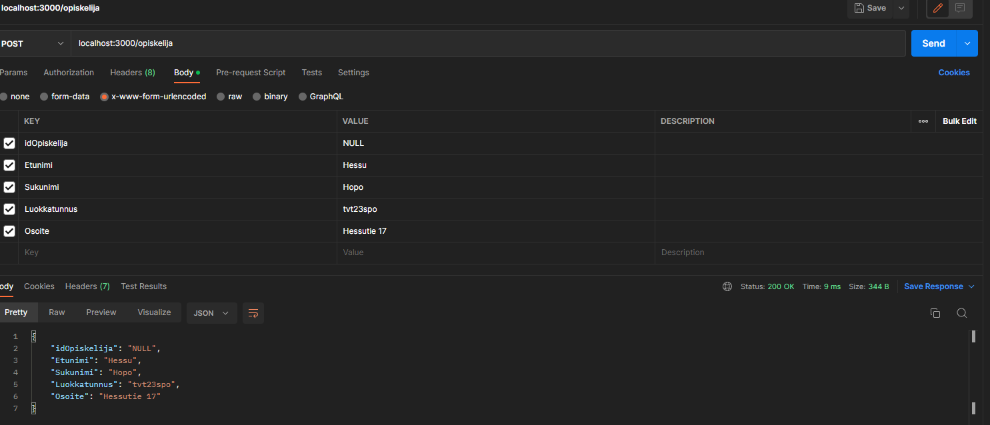

POST Hessu Hopo

PUT Osoite ’Ankkalinna 313’ -> ’Ankkalinnantie 13’

DELETE from arviointi